Fantasy Mission
Game Design Document (GDD)
Jaakko Uitto
Table of contents
1 Introduction 1
1.1 Game Name 1
1.2 Team 1
1.3 Date of last update 1
2 Game Overview 2
2.1 Game Concept 2
2.2 Target Audience 2
2.3 Genre(s) 2
2.4 Game Flow Summary 2
2.5 Look and feel 2
2.6 Hook 3
2.7 Competitive Analysis 3
2.8 Game Engine 3
3 Gameplay 4
3.1 Objectives 4
3.2 Game Progression 4
3.3 Play Flow 4
3.4 Challenge Structure 4
4 Mechanics 5
4.1 Rules 5
4.2 Interaction Model 6
4.3 Objects 6
4.4 Actions 6
4.5 Combat 6
4.6 Replaying and Saving 7
4.7 Events 7
4.8 Power-Ups 7
5 Story 9
5.1 Premise 9
5.2 Setting 9
5.3 Backstory 9
5.4 Plot Elements 9
5.5 Story Progression 9
6 Game World 10
6.1 General Look and Feel 10
6.2 Areas 10
6.2.1 World Area 10
6.2.2 Terrains 10
6.2.3 Arctic Areas 10
6.2.4 Tundra Areas 11
6.2.5 Variety Area 11
6.2.6 Desert Area 11
7 Characters 12
7.1 Settler 12
7.1.1 Description 12
7.1.2 Statistics 12
7.1.3 Abilities 12
7.2 Warrior 12
7.2.1 Description 12
7.2.2 Statistics 12
7.2.3 Abilities 12
7.3 Archer 13
7.3.1 Description 13
7.3.2 Statistics 13
7.3.3 Abilities 13
7.4 Scout 13
7.4.1 Description 13
7.4.2 Statistics 13
7.4.3 Abilities 13
7.5 Mage 14
7.5.1 Description 14
7.5.2 Statistics 14
7.5.3 Abilities 14
7.6 Hero 14
7.6.1 Description 14
7.6.2 Statistics 14
7.6.3 Abilities 14
8 Levels 16
8.1 Generated Map 16
8.1.1 Synopsis 16
8.1.2 Objectives 16
8.1.3 Level Details 16
9 Interface 17
9.1 Visual System 17
9.1.1 Faction Selection Screen 17
9.1.2 Game Screen 17
9.1.3 Turn Start Screen 18
9.1.4 Diplomacy Menu 18
9.1.5 Production Menu 19
9.1.6 Victory Screen 19
9.1.7 Camera model 20
9.2 Control System 20

Introduction
The following is a Game Design Document (GDD) of the game.

Game Name
The game is called Fantasy Mission.

Team
The team is just one person, Jaakko Uitto.

Date of last update
The last update was on 28.3.2026.

Game Overview

Game Concept
The game idea is that it’s a mix of Sid Meier’s Civilization games and A Game of Thrones: The Board Game. The players will go around a “board” where there are cities that can be captured and they can create units, as well as heroes that have their own tools, equipment and some special abilities that can be developed further as they gain experience. These abilities manifest in a form of using cards in a battle, which can turn the tide of the battle. There are ultra-powerful events that affect the game world without the players having any way of stopping them. These events act as surprises that may change the tide of the game. The winner is the one who defeats all opposing players.

Target Audience
The target audience is people who enjoy fantasy and strategy games, but don’t want to get into the overly complex grand strategy genre. More specifically, a more general audience of teenagers to adults in the western world. The estimated target rating is either 7 or 12.
The target platform is PC.

Genre(s)
Turn-based strategy.

Game Flow Summary
The player moves through the game using a floating camera that can move around the game world. The player can select units and cities to view more information about them, as well as select actions that the player wants the units and cities to do. These actions can be moving the units, creating units, etc.

Look and feel
The game is in 3D with a top-down view. It is essentially a living board game with medieval fantasy elements. The world looks like a board game laid out on a table. The units and heroes look like living board game pieces and the use of cards for ultra-powerful events and abilities add to that feel.

Hook
Fantasy Mission has events that affect the gameplay outside of the players’ choices. There are hero characters that are stronger than normal units. Rock-paper-scissors style elements in combat.

Competitive Analysis
Similar games on the market include Sid Meier’s Civilization series, Humanity, Endless Legend and the Age of Wonders series.

Game Engine
Unreal Engine 5. Specifically, version 5.5.4.

Gameplay

Objectives
The biggest objective of the game is to defeat the other players, which happens by taking all their locations and defeating all their units. Other objectives are expanding your territory, upgrading your cities and levelling up your units.

Game Progression
The game progression happens in two ways. First is building up your cities and upgrading your units and heroes. This happens by your units gaining experience and using resources for the upgrades. This makes your units and heroes stronger, grows your army and makes your cities produce more resources. Second is expanding your territory. By taking over locations from other players and founding new locations, you can expand your territory, which gives you more resources and ability to create more units.

Play Flow
The game starts with the player having only one Settler. The player will then proceed to explore the area and use the resources gained from the land to expand their territory. When the player comes across an opponent, they can proceed to engage in diplomacy or go to battle with them for their territory. When the player’s units go to battle, they gain experience that allows them to gain levels that can allow them to become stronger. As the game goes on, the opponents also grow stronger as they gain experience, which makes the game progressively more difficult. This is all completely up to the player to do as they wish. The estimate for how long the game can take is up to 2 hours, but it can end quickly as well depending on player strategies.

Challenge Structure
The challenge structures are not linear. Basically, the player must keep producing more and more units and heroes to be able to combat the opposition as the game goes on, as well as found new cities to gain more land to get more resources.

Mechanics

Rules
Each player takes turns to complete their objectives. A player cannot complete actions during other players’ turns.

Creating units takes resources. The number of resources needed to create depends on the type of unit. Units can also be upgraded into heroes if they meet certain conditions. If a faction has no money, they cannot produce more units.

Units can move only a certain number of spaces. This number depends on the attribute values of that unit.

During battle, the opposing sides can complete only a certain number of actions based on the unit’s action points and the actions the units know. The number is specific to the unit type. The battle is decided by the damage done to the units and heroes, and it occurs in turns just like any other action in the game.

Units and heroes that have magic abilities adhere to a rock-scissors-paper pattern. There are elements that work well or badly against each other based on a chart that is currently unspecified. These elements are Fire, Water, Earth and Wind. Fire beats Wind, Water beats Fire, Earth beats Water and Wind beats Earth. There is also a Neutral element for non-magic based abilities.

Capturing cities happens by completing a siege. During a siege, units and heroes battle against the city’s defences until either side loses or the sieging party calls off the siege. When a city’s health drops to zero, it’s ownership is transferred to the attacking faction.

Ultra-powerful events occur at random points in the game. These events can change the game rules. They give power-ups to different unit types.

The winner of the game is the last faction with units or cities. A player with no units or cities is eliminated from the game.

Interaction Model
Every object on the board is constrained to moving on tiles. Some tiles are inaccessible. Each tile has its own movement modifier that specifies how many unit actions it takes for a unit to move to it. The player moves using a floating camera that can move over the game board.

Units on a board can interact with other units, as well as cities and ruins. When a unit interacts with other units, a battle ensues. When a unit interacts with a city of another faction, it sieges it. When a unit interacts with a ruin, it receives a power-up that gives it an ability that they previously did not have.

Factions interact with each other through diplomacy. The factions can be in a state of war, alliance, hostile or friendly. If a faction is hostile, it does not allow the opposition to enter its borders. If a faction is friendly, it allows the opposition to enter its borders.

Factions can collect resources from map tiles within its borders. These resources can be used to create new units and heroes.

Objects
The movable objects in the game for the player are the units. These can be moved by selecting them and then selecting a tile to move them to. Other objects in the world are cities and ruins, and they cannot be moved.

Actions
Actions that the player can take during a turn are moving units, changing production that happens in a city, communicating with other players through diplomacy, and using unit actions, like attacks, movement and founding new cities.

Diplomatic actions that can be taken are trade, alliance and declaration of war.

Combat
Combat occurs through battles. The battle is turn-based combat that occurs during the player turns same as any other actions in the game. In battle, the player order units to attack specific units or flee from the battle. Other players and units can also join in an already existing battle, as the battle occurs on the gameboard where every action happens. The combat ends once its either called off, one side flees or all units on the opposing side are defeated.

Replaying and Saving
The replayability of the game is high due to the random nature of it. The units spawn to random tiles, and the game world itself is randomized. Players can choose from different factions that exist, which all have different appeal to them.

There are no save mechanics in the game.

Events
There are several types of ultra-powerful events that can occur randomly for a random duration lasting from 1 turn to 10 turns.

Element Boost gives a 2x damage bonus to attacks of the given element, which can be any of the four main Elements: Fire, Water, Earth and Wind.

Unit Boost gives 2x damage bonus to the units of the specific type, which can be any of the units, except for Settlers.

EXP Boost gives a 2x experience gain to all units and cities.

No Boost gives no additional effects of any kind.

Power-Ups
There are several types of power-ups the units can receive from the ruins.

Attribute Boost gives the unit an extra point to a random stat, with the possibilities being actions per turn, attack, defence and health.

New Action gives the unit a new action, which can be either Ranged Attack or Magic Attack.

Level Up simply increases the unit’s level by 1.

Become Hero makes the unit into a Hero character.

Story

Premise
Take control of a faction and lead them to victory with the aid of your heroes and magic. May the best heroes win!

Setting
Fantasy medieval setting with magic.

Backstory
The backstory of the game is that there are multiple factions in this fantasy world that are looking to bring peace to the world. These factions have their own motives and reasons for doing so. There has been a catastrophe that wiped out all civilization, and now the people are rebuilding their world.

Plot Elements
There are four factions in the game: Earth Nation, Fire Nation, Water Nation and Wind Nation. These all control one element in the game, these being Earth, Fire, Water and Wind. Each nation can produce people with different elements to the major element of their faction, but this is rarer than producing people with the major element.

At the start, the player doesn’t necessarily know anything about the world, but as they explore the world, they gain more knowledge about it by discovering ruins and other factions.

Ultra-powerful events cause different modifiers to occur during the game at random points, which can influence the narrative.

Story Progression
The player starts as one faction and proceeds to make that faction the strongest faction in the world, competing against other factions. Diplomacy with other factions influences the story, which is self-indulgent by the players with their actions.

Game World

General Look and Feel
The world looks like a game board, with the medieval fantasy setting with, mages, warriors, etc. The units are bigger than the cities to help with players seeing them on the map.

Areas

World Area
The main area is the board itself, where everything occurs. The different map tiles are randomly added to the map, with different areas within the board that have different terrain. These tiles have their own resources and specific movement. It is randomly generated at the start of the game. The area is a 30x30 grid of hexagonal tiles. Cities can be founded on any tile that is not Ocean terrain, and ruins can spawn randomly anywhere that is not an Ocean terrain.

Terrains
Therea are ten different terrain types: plain, hills, mountains, swamp, marsh, glacier, ocean, plateau, desert and tundra. They each have their unique movement modifiers that affects unit movement. Plain and tundra have the modifier of 1. Hills, Marsh, Plateau and Desert have the modifier of 2. Swamp and Glacier have the modifier of 3. Mountains have the modifier of 4. Oceans are inaccessible. Resources are allocated to the tiles randomly based on the terrain type. Food can appear in any tile that is not Mountains, Swamp, Plateau or Desert. Production can appear in any tile that is not Plain, Marsh, Ocean or Tundra. Wood can only appear in Hills, Marsh and Tundra.

Arctic Areas
The arctic areas are located on the northern and southern edges of the of the map. The terrains that can spawn in this area are Glacier and Ocean. The arctic areas are always just one tile wide and there are two of them.

Tundra Areas
The tundra areas are in-between arctic and variety areas. The terrains that can spawn in this area are Tundra, Plain and Mountains. There are two tundra areas, one in the north and one in the south, totalling 1/4th of the whole map.

Variety Area
The variety areas span most of the map. There are two of them in-between the tundra areas and the desert area. The terrains that can spawn in this area are Plain, Hills, Swamp, Marsh and Plateau.

Desert Area
The desert is an area with only the Desert terrain, located in the middle of the map. It spans 1/4th of the map.

Characters

Settler

Description
Settlers are weak in a fight, but they can create cities.

Statistics
Settlers have 4 actions per turn. Their attack and defence stats are 1. Health is 5. Production cost is 5 and maintenance cost is 1. The experience yield when killed is 10.

Abilities
Settlers can use the Move action like all units. They can use the Attack action, which allows them to attack nearby units. They can also use the Settle action to settle a new city.

Warrior

Description
Warriors are basic units that fight for the faction they were born in. They can only attack at a short range.

Statistics
Warriors have 5 actions per turn. They have an attack and defence of 4. Their health is 10. Production cost is 3, and maintenance cost is 2. The experience yield when killed is 40.

Abilities
Warriors can use the Move action like all units. They can use the Attack action to attack nearby units.

Archer

Description
Archers are basic units that fight for the faction they were born in. They can attack long-range as well as short-range.

Statistics
Archers have 5 actions per turn. Their attack and defence stats are 3. Health is 8. Production cost is 3, and maintenance cost is 2. The experience yield when killed is 40.

Abilities
Archers can use the Move action like all units. They can use Attack action to attack nearby units. They can also use Ranged Attack to attack units at long range.

Scout

Description
Scouts are not necessarily fighters, but they can fight if necessary. They are fast and good at moving across the map.

Statistics
Scouts have 7 actions per turn. Their attack and defence stats are 2. Health is 7. Production cost is 2, and maintenance cost is 1. The experience yield when killed is 20.

Abilities
Scouts can use the Move action like all units. They can also use the Attack action to attack nearby units.

Mage

Description
Mages are mysterious people who can use the arcane arts known as Magic. Each of them can use one Element to power their attacks. Mages are the strongest units in the game. They can attack long-range with magic attacks.

Statistics
Mages can use 4 actions per turn. Their attack is 6. Defence is 4. Health is 6. Production cost is 4, and maintenance cost is 3. The experience yield when killed is 50.

Abilities
Mages can use the Move action like all units. They can also use Attack action to attack nearby units. They have a unique ability called Magic Attack, which uses the Element assigned to the unit to deal damage according to the opposing unit’s Element, using the rock-paper-scissors style system of strengths and weaknesses. Magic Attack is a long-range attack.

Hero

Description
Heroes are created and born in battle. Everyone in the land aspires to become a hero one day. Every unit can become a hero under right circumstances. They can utilize a strong Hero Attack.

Statistics
Heroes retain their original statistics, as they keep the unit classification they started with, but with a times 2 boost to attack, defence and health.

Abilities
Heroes retain the abilities they had as normal units, but they gain a new ability called Hero Attack, which is a long-ranged attack, and uses the Element assigned to the unit just like Magic Attack.

Levels

Generated Map

Synopsis
Procedurally generated map that the players can move their units around and find cities.

Objectives
The objectives of the level are the same as the goals of the game: capturing opposing locations, building your army and being the last faction left standing.

Level Details
The players spawn on the map with one Settler and they can find a city and continue building their faction up. Combat also occurs here. The units can also find ruins here that give them a power-up.

Interface

Visual System
The visual system in use was made with the Unreal Engine widget blueprints.

Faction Selection Screen
The first screen the player sees when the game is opened is the faction selection screen. This is where a new game starts. This screen allows for the player to modify the game that is being started by choosing the number of players in the game, as well as their factions and names.
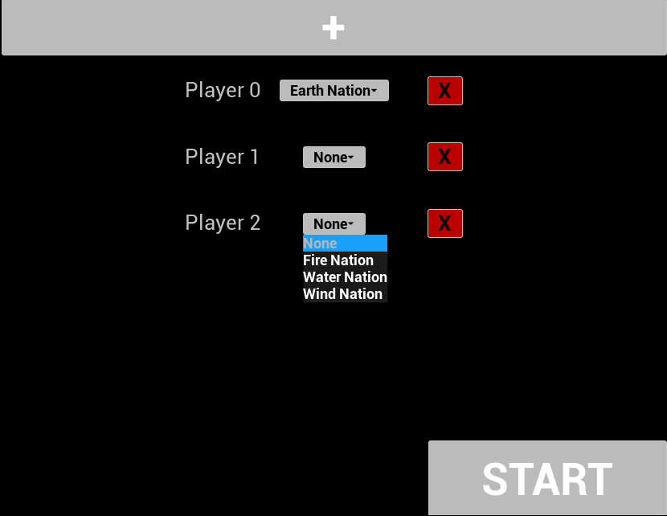

Game Screen
The game screen is the main screen that the player will use. This screen contains the game world and the game itself. It has a HUD with a resource list, a player list button, a unit list, a button for next turn, a world event button on top of the screen that can display the current ultra-powerful event that is occurring, and a quit button. Each unit, city and ruin has a UI tag above them that displays their health, experience and name.

The HUD also contains an action overlay that displays potential actions the selected unit or city can do, as well as an overlay of information on the map tile that is currently hovered. When attacking, the map tiles in range of the attack are highlighted red. When moving, the tiles in the movement path are highlighted blue. Selected and hovered units and locations are highlighted blue.

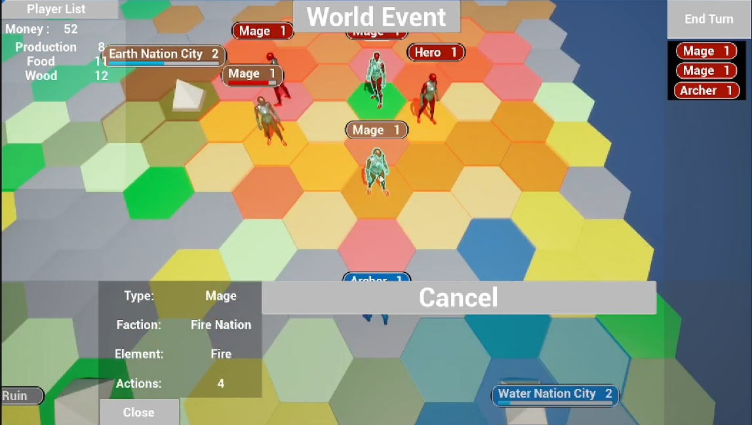

Turn Start Screen
When the next turn button is pressed, it displays a turn start screen, which simply states the turn-player’s display name, with a button to start the next turn.

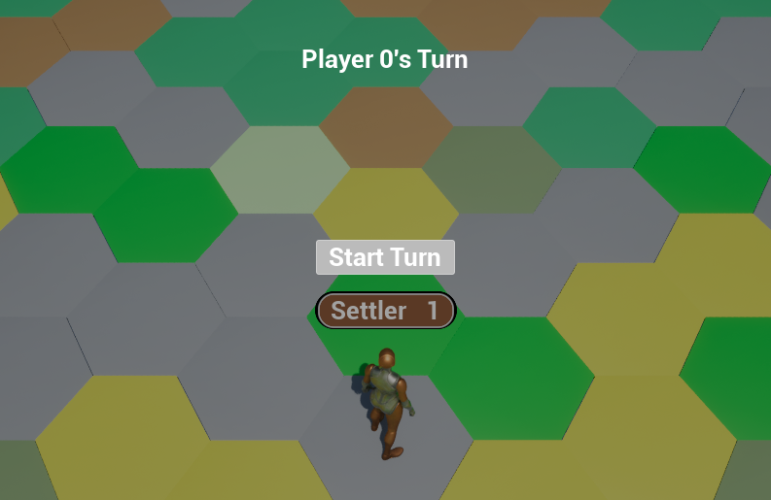

Diplomacy Menu
When the player list button is pressed, it opens the diplomacy menu. This is where the player can interact with other players by declaring a war, offering peace, offering an alliance or dissolving an alliance. It displays each player in the game, with their faction and their relationship with the turn-player.

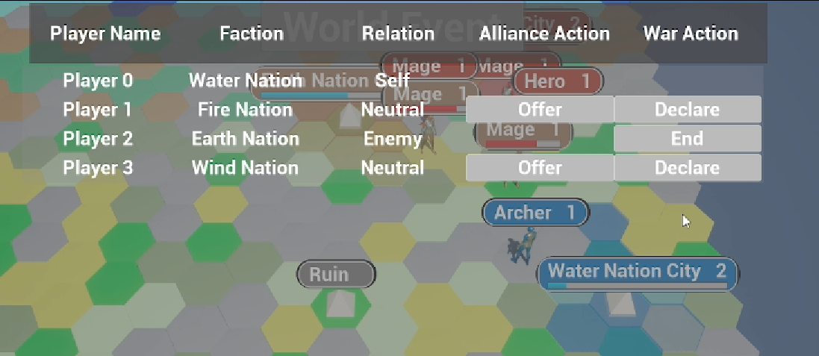

Production Menu
When an owned city is selected, the production menu can be opened to open the production menu. This shows a list of units that can be produced and the resources needed to produce them. The production action can be cancelled.

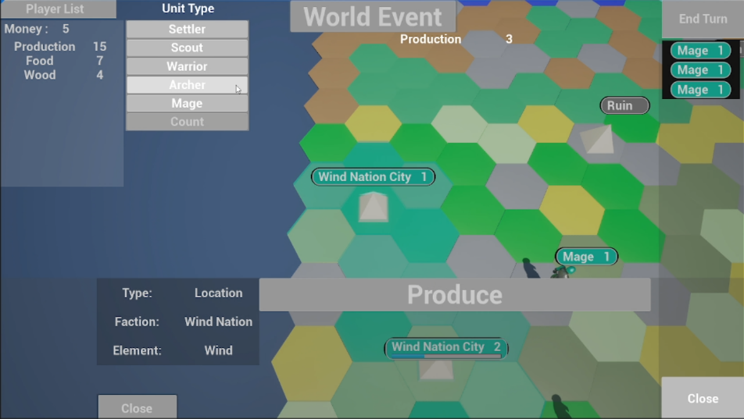

Victory Screen
When the game is won, it shows the victory screen, with the name of the player, with buttons to either restart the game or quit the game.

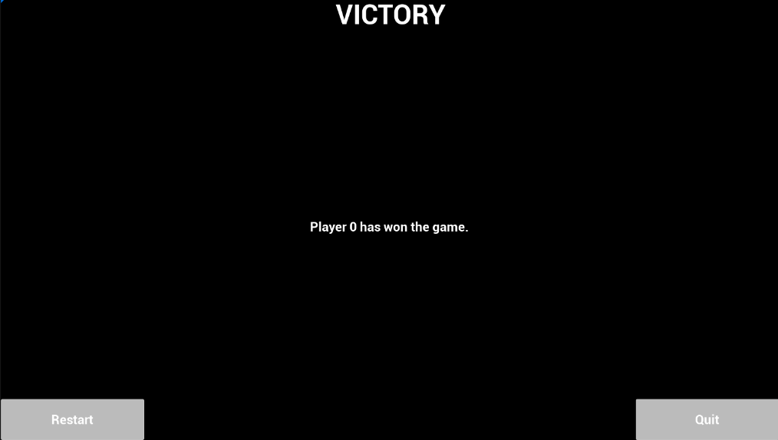

Camera model
The camera in use is a top-down floating camera that can be moved by the turn-player.

Control System
The camera can be controlled with the right mouse button, WASD or the arrow keys. Units and locations can be selected with left mouse button. If holding CTRL, multiple units and locations can be selected. Buttons can be pressed with the left mouse button or by navigating to them with the arrow keys and pressing ENTER.

